K10 Programmable Beacon Lights
Programmable K10 beacon lights can be identified by the presence of 5 wires, red, black, yellow, white and blue. A picture of a programmable K10 beacon light is shown below. The wiring instructions cover both the single and dual color units.

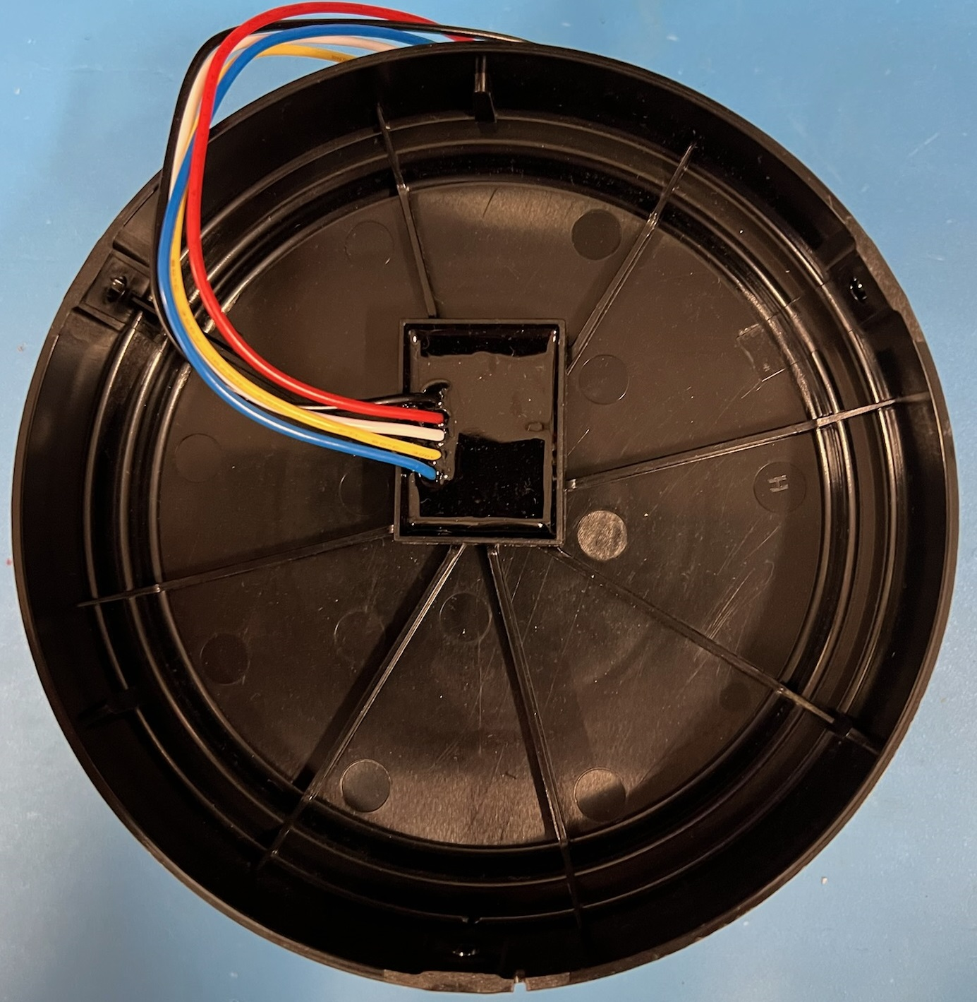

1. Connect the black wire to ground.
2. Connect the red wire (+) to a switched +12V / 24 volt DC connection. With ground connected, when the + connection has power, the unit will start flashing and continue to flash until +V is removed from the red wire.
3. Connect the yellow wire to a switched +12/24V connection. When the yellow wire has power the unit will flash dimmer than if the yellow wire had no power supplied. This is referred to as ‘night mode’.
4. If required, connect the blue wire to +12/24V and the unit will shift its light patten by 50%. So if you have two beacon lights and one has the blue wire connected and one that doesn’t, the lights will flash in a ‘wig wag’ style pattern.
5. For programming, momentarily touch the white wire to +12/24V and the unit will advance to the next flash pattern. You can continue to change patterns by repeating the momentary connection of the white wire to the +V supply.
There are a total of 7 flash patterns for single color beacon lights and 10 flash patterns for dual color lights. Once the maximum flash pattern is selected, touching the white wire to +V will reset the unit and it will go back to flash pattern 1.

